TIS2151Web Application Development

Assignment Submission Cover Grading Sheet: Assignment 1 (10%)

Due Date: 1st Sept 2015 (Tuesday) before 5.00 p.m.

No | Student Name | Student ID | Final Score
1 | Muhammad Redza Bin Ruslan | 1102700453
2 | Muhammad Aiman Bin Kamal | 1102700205
3 | Ahmad Nazreen Bin Ahmad Kamarulzaman | 1102703236
4 | Imran Bin Ab Azmar | 1112702852

Item Required By Instructor to Hand-in
☑Softcopy
Assignment Cover Page ◻
HTML Coding ◻

Program Grading
(To Be Filled Out By The Instructor)

 | Grading Elements
Items | Total (25%) |  | Remarks
Part 1
Part 2
Part 3
Part 4
Overall Score (100%)
Late Submission Penalty 2marks x ____ Day(s)
Final Score

Due Date: 1st Sept 2015 (Tuesday) before 5.00 p.m.

Minimum number of member is 3 and maximum is 4.

Things to submit:
The softcopy should contains the following files in a zip file and emailed to fci.tis2151@gmail.com :
1] assignment submission cover with grading sheet
2] solutions for all question (source code and instruction, if any)

Important: Please make sure you use the following format as the subject of your email:
TIS2151 Assignment 1 [List of Student IDs]
Remarks:
** Include your group member name and ID in the footer of your HTML pages.

** Late submission: 2 marks per day
Important: copying is a serious offense, all act of cheating will be penalized.

For this assignment, you are required to develop a webpage for FCI.

Aside from the required elements below, the layout and content of your web page are entirely up to you. You are encouraged to be creative.

At a bare minimum, your page must provide the following:

Part 1
Your page should have at least two different parts, one containing some details about FCI, and another part a set of links to navigate through your website and external sites. You should include both internal links (that jump to locations within the info page) and external links that would lead to other pages on the web.
Your info page must have MMU logo and FCI name on the top.

Part 2
Your info page should perform some text formatting (bold, italics, color, BIG) .
There should be at least one list.
There should be at least 5 links in the page, including a link to the MMU website. At least one of those links must occur in a sentence.
Create a simple feedback form for the page.

Part 3
There should be at least 2 images in the page, one of which must be stored locally along with the Web page, and another online image.
There must be at least one table, some of whose rows are more than one line long.
Your page must make use of a style sheet that defines basic formatting style, including the format of tables. The style sheet should be defined in a separate file and linked to your page (external CSS).

Part 4
Your homepage should have a nice (professional) look and its code should satisfy common standards. In particular, for maximum points here, your webpage shoud satisfy the HTML5 standards (including a proper Document Type Declaration in the HTML file). You should pass it through the W3C validator.

Important note: Your page should use standard HTML (and CSS) features only, so that it will be viewable using Internet Explorer, Netscape (Firefox), Opera, Safari, Chrome, etc. While it may not look exactly the same due to inconsistencies and variations in the browser implementations, your page should look reasonable under any such browser.

Live version of this website can be found at: http://tis2151.github.io

1. Home
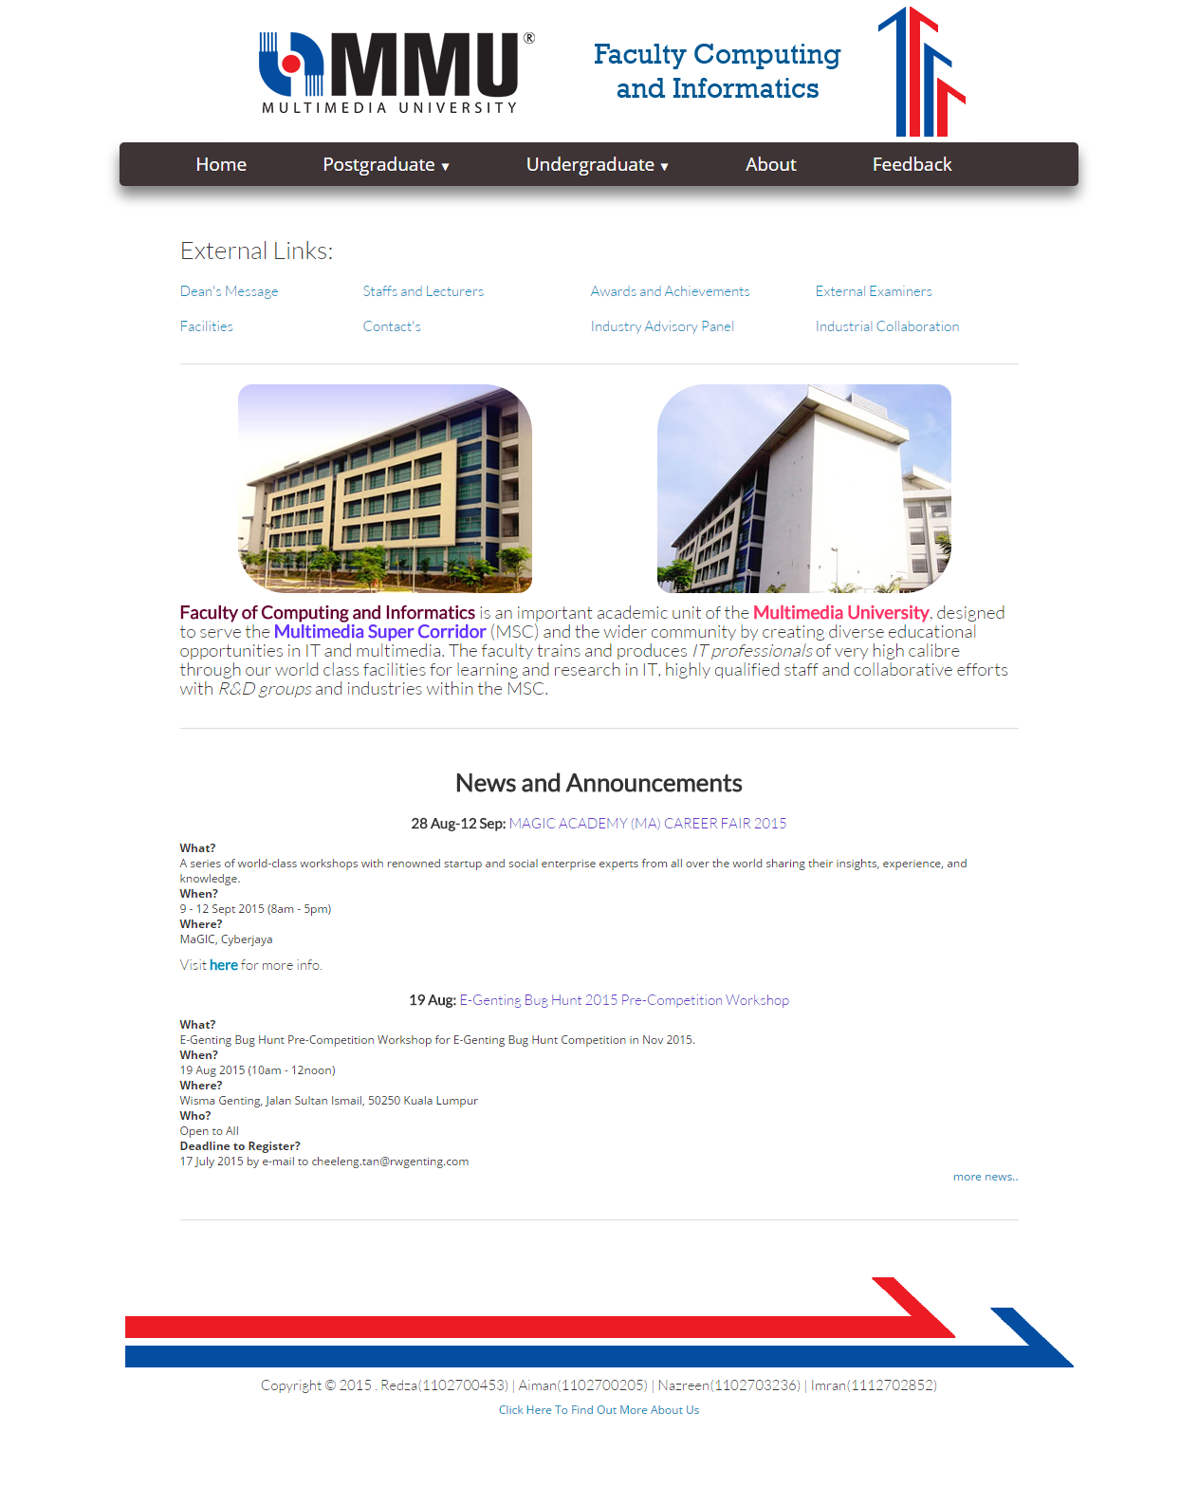
Image 1 : Home Page
<!--index.html-->
<!DOCTYPE html>
<html>
<head>
<title>TIS2151</title>
<link rel="icon" type="image/png" href="image/pagecon.png">
<meta charset=”utf-8”>
<meta name="viewport" content="width=device-width, initial-scale=1">
<link rel="stylesheet" href="css/bootstrap.css">
<link rel="stylesheet" href="css/page.css">

</head>

<body width="80%" style="margin:auto">
<center>
<a href="http://tis2151.github.io/"><img src="image/header.png" alt="header logo"></a><br>

<div class="menu-wrap">
<nav class="menu">
<ul class="clearfix">
<li><a href="http://tis2151.github.io/">Home</a></li>
<li><a href="#">Postgraduate <span class="arrow">&#9660;</span></a>
<ul class="sub-menu">
<li><a href="programmes.html">Programmes</a></li>
<li><a href="research.html">Research Centres</a></li>
</ul>
</li>
<li><a href="#">Undergraduate <span class="arrow">&#9660;</span></a>
<ul class="sub-menu">
<li><a href="foundation.html">Subject List for Foundation Programme</a></li>
<li><a href="bachelor.html">Subject List for B.CS with Specialization</a></li>
</ul>
</li>
<li><a href="about.html">About</a></li>
<li><a href="feedback.html">Feedback</a></li>
</ul>
</nav>
</div>
<br>

<!--CONTENT START HERE-->

<table width="70%">
<tr>
<th style="text-align: left;" colspan="4"><h3>External Links:</h3></th>
</tr>
<tr>
<td><h5><a href="http://fci.mmu.edu.my/thefaculty/deanmsg.php" target="_blank">Dean's Message</a></h5></td>

<td><h5><a href="http://fci.mmu.edu.my/staffpage/staffmain1.php" target="_blank">Staffs and Lecturers</a></h5></td>

<td><h5><a href="http://fci.mmu.edu.my/thefaculty/new_awards.php" target="_blank">Awards and Achievements</a></h5></td>

<td><h5><a href="http://fci.mmu.edu.my/staffpage/ext_examiners.php" target="_blank">External Examiners</a></h5></td>
</tr>
<tr>
<th>Where?</th>
<td><h5><a href="http://fci.mmu.edu.my/thefaculty/labs.php" target="_blank">Facilities</a></h5></td>

<td><h5><a href="http://fci.mmu.edu.my/thefaculty/contact_us.php" target="_blank">Contact's</a></h5></td>

<td><h5><a href="http://fci.mmu.edu.my/staffpage/industry_adv.php" target="_blank">Industry Advisory Panel</a></h5></td>

<td><h5><a href="http://fci.mmu.edu.my/thefaculty/new_collaboration.php" target="_blank">Industrial Collaboration</a></h5></td>
</tr>
<tr><td colspan="4"><hr></td></tr>
<tr>
<td style="text-align: center;" colspan="2"><img class="rcorners1" src="image/mmu4.jpg" alt="Internal Image FCI Building"></td>
<td style="text-align: center;" colspan="2"><img class="rcorners2" src="http://fci.mmu.edu.my/main/images/fit_new_building2.jpg" alt="External Image FCI Building"></td>
</tr>

<tr>
<th colspan="4"><h4><strong><font color="#660033">Faculty of Computing and Informatics</font></strong> is an important academic unit of the <strong><font color="FF3366">Multimedia University</font></strong>,
designed to serve the <strong><font color="#6633FF">Multimedia Super Corridor</font></strong> (MSC) and the wider community by creating diverse educational
opportunities in IT and multimedia. The faculty trains and produces <i>IT professionals</i> of very high calibre
through our world class facilities for learning and research in IT, highly qualified staff and collaborative
efforts with <i>R&D groups</i> and industries within the MSC.</h4></th>
</tr>

<tr><td colspan="4"><hr></td></tr>
</table>

<table width="70%">
<tr>
<th style="text-align: center;"><h3><strong>News and Announcements</strong></h3></th>
</tr>
<tr>
<td style="text-align: center;"><h5><strong>28 Aug-12 Sep:</strong> <font color="#6633CC">MAGIC ACADEMY (MA) CAREER FAIR 2015</font></h5></td>
</tr>
<tr>
<th>What?</th>
</tr>
<tr>
<td>A series of world-class workshops with renowned startup and social enterprise experts from all over the world sharing their insights, experience, and knowledge.</td>
</tr>
<tr>
<th>When?</th>
</tr>
<tr>
<td>9 - 12 Sept 2015 (8am - 5pm)</td>
</tr>
<tr>
</tr>
<tr>
<td>MaGIC, Cyberjaya</td>
</tr>
<tr>
<td style="text-align: left;"><h5>Visit <a href="http://academy.mymagic.my/" target="_blank"><strong>here</strong></a> for more info.</h5></td>
</tr>

<tr>
<td style="text-align: center;"><h5><strong>19 Aug:</strong> <font color="#6633CC">E-Genting Bug Hunt 2015 Pre-Competition Workshop</font></h5></td>
</tr>
<tr>
<th>What?</th>
</tr>
<tr>
<td>E-Genting Bug Hunt Pre-Competition Workshop for E-Genting Bug Hunt Competition in Nov 2015.</td>
</tr>
<tr>
<th>When?</th>
</tr>
<tr>
<td>19 Aug 2015 (10am - 12noon)</td>
</tr>
<tr>
<th>Where?</th>
</tr>
<tr>
<td>Wisma Genting, Jalan Sultan Ismail, 50250 Kuala Lumpur</td>
</tr>
<tr>
<th>Who?</th>
</tr>
<tr>
<td>Open to All</td>
</tr>
<tr>
<th>Deadline to Register?</th>
</tr>
<tr>
<td>17 July 2015 by e-mail to cheeleng.tan@rwgenting.com</td>
</tr>
<tr>
<td style="text-align: right;"><a href="http://fci.mmu.edu.my/news/newsmain2.php#news" target="_blank">more news..</a>
</tr>

<tr><td><br><hr><h3>&nbsp;</h3></td></tr>
</table>

<!--CONTENT END HERE-->

<table>
<tr><td style="text-align: center;"><img src="http://i.imgur.com/W01bvc0.png" alt="external link footer image"></td></tr>
<tr><td style="text-align: center;"><h5>Copyright &copy; 2015 . Redza(1102700453) | Aiman(1102700205) | Nazreen(1102703236) | Imran(1112702852)</h5></td></tr>

<tr><td style="text-align: center;"><a href="aboutus.html">Click Here To Find Out More About Us</a></td></tr>
</table>

<h1>&nbsp;</h1>
</center>
</body>
</html>

2. Postgraduate Programmes
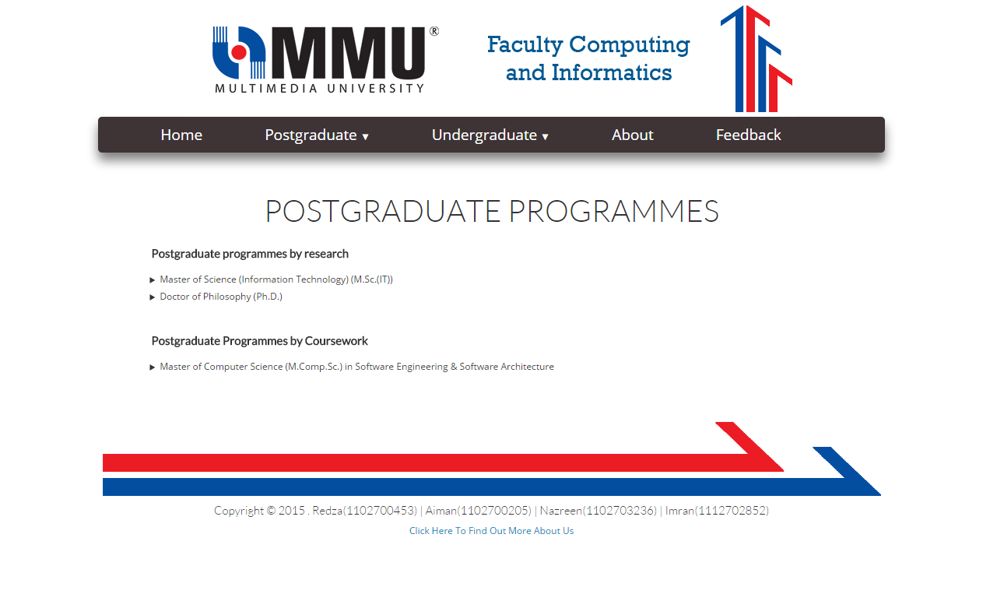
Image 2 : Postgraduate Programmes Page

<!--programmes.html-->
<!DOCTYPE html>
<html>
<head>
<title>Programmes</title>
<meta charset="utf-8" />
<link rel="icon" type="image/png" href="image/pagecon.png">
<meta charset=”utf-8”>
<meta name="viewport" content="width=device-width, initial-scale=1">
<link rel="stylesheet" href="css/bootstrap.css">
<link rel="stylesheet" href="css/page.css">

</head>

<body>

<body width="80%" style="margin:auto">
<center>
<a href="http://tis2151.github.io/"><img src="image/header.png" alt="header logo"></a><br>

<div class="menu-wrap">
<nav class="menu">
<ul class="clearfix">
<li><a href="http://tis2151.github.io/">Home</a></li>
<li><a href="#">Postgraduate <span class="arrow">&#9660;</span></a>
<ul class="sub-menu">
<li><a href="programmes.html">Programmes</a></li>
<li><a href="research.html">Research Centres</a></li>
</ul>
</li>
<li><a href="#">Undergraduate <span class="arrow">&#9660;</span></a>
<ul class="sub-menu">
<li><a href="foundation.html">Subject List for Foundation Programme</a></li>
<li><a href="bachelor.html">Subject List for B.CS with Specialization</a></li>
</ul>
</li>
<li><a href="about.html">About</a></li>
<li><a href="feedback.html">Feedback</a></li>
</ul>
</nav>
</div>
<br>

<!--CONTENT START HERE-->

<h1><span style="text-align: center;">POSTGRADUATE PROGRAMMES</span></h1>
<div>
<table width="70%">
<tr>
<th style="padding:5px"><h5><strong>Postgraduate programmes by research</strong></h5></th>
</tr>
<tr>
<td style="padding:3px"><details><summary>Master of Science (Information Technology) (M.Sc.(IT))</summary><br>
<span style="font-size:20px;font-weight:bold;">Faculty Of Computing & Informatics</span><br><br>
<table border="1">
<tr>
<th>Programme</td>
<th colspan="2">Mode of study</td>
<th>Cyberjaya</td>
<th>Melaka</td>
</tr>
<tr>
<td>Master of Science (Information Technology) (M.Sc.(IT))</td>
<td>Yes</td>
<td>Yes</td>
<td>Yes</td>
<td>No</td>
</tr>
<tr>
<td>Doctor of Philosophy (Information Technology)
[Ph.D.(I.T.)]</td>
<td>Yes</td>
<td>Yes</td>
<td>Yes</td>
<td>No</td>
</tr>

</table>
<br><br>
<span style="font-size:20px;font-weight:bold;">Faculty Of Information Science & Technology</span><br><br>
<table border="1">
<tr>
<th>Programme</td>
<th colspan="2">Mode of study</td>
<th>Cyberjaya</td>
<th>Melaka</td>
</tr>
<tr>
<td>Master of Science (Information Technology) (M.Sc.(IT))</td>
<td>No</td>
<td>No</td>
<td>No</td>
<td>Yes</td>
</tr>
<tr>
<td>Doctor of Philosophy (Information Technology)
[Ph.D.(I.T.)]</td>
<td>No</td>
<td>No</td>
<td>No</td>
<td>Yes</td>
</tr>

</table>
<br><br>
</details></td>
</tr>

<tr>
<td style="padding:3px"><details><summary>Doctor of Philosophy (Ph.D.)</summary><br>
<span style="font-size:20px;font-weight:bold;">Faculty Of Computing & Informatics</span><br><br>
<table border="1">
<tr>
<th>Programme</td>
<th colspan="2">Mode of study</td>
<th>Cyberjaya</td>
<th>Melaka</td>
</tr>
<tr>
<td>Master of Science (Information Technology) (M.Sc.(IT))</td>
<td>Yes</td>
<td>Yes</td>
<td>Yes</td>
<td>No</td>
</tr>
<tr>
<td>Doctor of Philosophy (Information Technology)
[Ph.D.(I.T.)]</td>
<td>Yes</td>
<td>Yes</td>
<td>Yes</td>
<td>No</td>
</tr>

</table>
<br><br>
<span style="font-size:20px;font-weight:bold;">Faculty Of Information Science & Technology</span><br><br>
<table border="1">
<tr>
<th>Programme</td>
<th colspan="2">Mode of study</td>
<th>Cyberjaya</td>
<th>Melaka</td>
</tr>
<tr>
<td>Master of Science (Information Technology) (M.Sc.(IT))</td>
<td>No</td>
<td>No</td>
<td>No</td>
<td>Yes</td>
</tr>
<tr>
<td>Doctor of Philosophy (Information Technology)
[Ph.D.(I.T.)]</td>
<td>No</td>
<td>No</td>
<td>No</td>
<td>Yes</td>
</tr>

</table>

</details></td>
</tr>
</table></div>
<br>
<div>
<table width="70%">
<tr>
<th style="padding:5px"><h5><strong>Postgraduate Programmes by Coursework</strong></h5></th>
</tr>
<tr>

<td style="padding:3px"><details><summary>Master of Computer Science (M.Comp.Sc.) in Software Engineering & Software Architecture</summary><br>
<p>
<strong>Multimedia University</strong> is committed to produce and train quality IT workers to help the country to propel into the information age. To accelerate this production and meet the unprecedented demand for multimedia and IT professionals, Multimedia University offers a Master’s degree in Computer Science (M.CS) specializing in Software Engineering and Software Architecture (SESA). This course is targeted at IT and computer science graduates and aims to produce qualified IT professionals who specialize in software engineering and software architecture.
The world is moving towards a knowledge economy where information grows at a fast speed. The number of large-scale software projects require well-trained personnel to design and manage is increasing. Furthermore, managers in business organisations need good information and assistance to make critical decisions from factual data. This creates a need to train qualified professionals to fulfill this demand. Our objectives are to produce:
<ul>
<li>software professionals who are well-versed in advanced theories and practices in the architecture and engineering of large-scale and long-term software systems.</li>
<li>analytics professionals who have the ability to perform data analysis and use analytics to manage today's business environment.</li>
<li>leaders, critical thinkers and technopreneurs in IT for knowledge economy.</li>
</ul>
</p>

</table>

</details></td>
</tr>
</table></div>

<!--CONTENT END HERE-->

<h3>&nbsp;</h3>
<table>
<tr><td style="text-align: center;"><img src="http://i.imgur.com/W01bvc0.png" alt="external link footer image"></a></td></tr>
<tr><td style="text-align: center;"><h5>Copyright &copy; 2015 . Redza(1102700453) | Aiman(1102700205) | Nazreen(1102703236) | Imran(1112702852)</h5></td></tr>
<tr><td style="text-align: center;"><a href="aboutus.html">Click Here To Find Out More About Us</a></td></tr>
</table>

<h1>&nbsp;</h1>
</center>
</body>
</html>

3. Research Centre
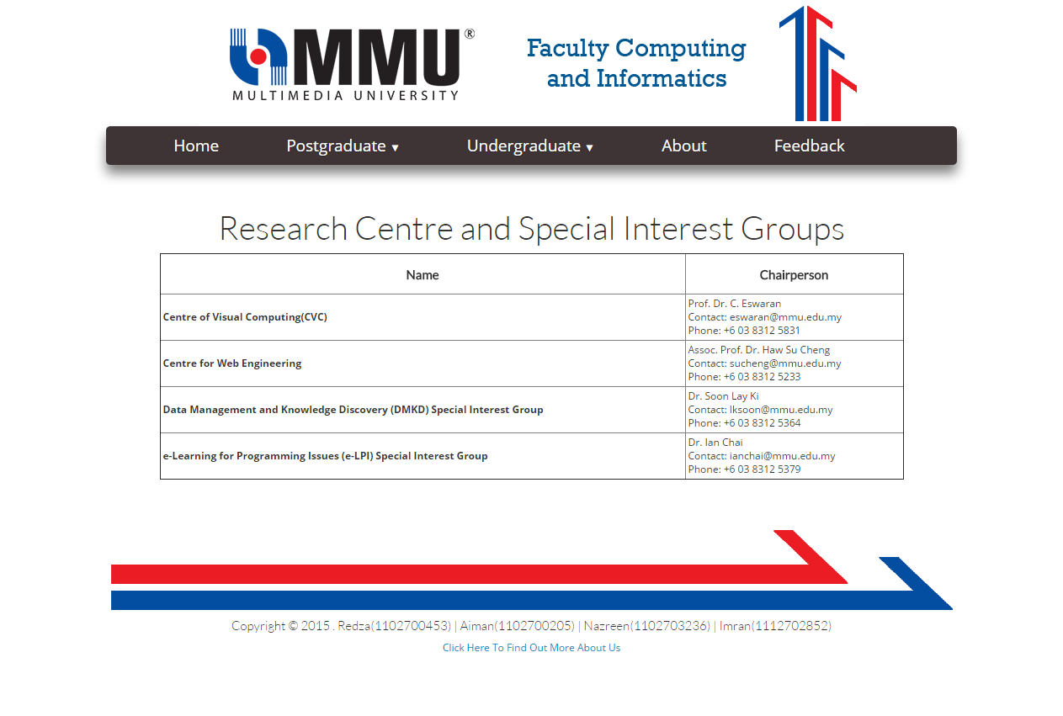
Image 3 : Research Centre Page
<!--research.html-->
<!DOCTYPE html>
<html>
<head>
<title>Research</title>
<meta charset="utf-8" />
<link rel="icon" type="image/png" href="image/pagecon.png">
<meta charset=”utf-8”>
<meta name="viewport" content="width=device-width, initial-scale=1">
<link rel="stylesheet" href="css/bootstrap.css">
<link rel="stylesheet" href="css/page.css">

</head>

<body>

<body width="80%" style="margin:auto">
<center>
<a href="http://tis2151.github.io/"><img src="image/header.png" alt="header logo"></a><br>

<div class="menu-wrap">
<nav class="menu">
<ul class="clearfix">
<li><a href="http://tis2151.github.io/">Home</a></li>
<li><a href="#">Postgraduate <span class="arrow">&#9660;</span></a>
<ul class="sub-menu">
<li><a href="programmes.html">Programmes</a></li>
<li><a href="research.html">Research Centres</a></li>
</ul>
</li>
<li><a href="#">Undergraduate <span class="arrow">&#9660;</span></a>
<ul class="sub-menu">
<li><a href="foundation.html">Subject List for Foundation Programme</a></li>
<li><a href="bachelor.html">Subject List for B.CS with Specialization</a></li>
</ul>
</li>
<li><a href="about.html">About</a></li>
<li><a href="feedback.html">Feedback</a></li>
</ul>
</nav>
</div>
<br>

<!--CONTENT START HERE-->

<h1><span style="text-align: center;">Research Centre and Special Interest Groups</span></h1>
<div>
<table border="1" width="70%">
<tr>
<th style="padding:5px; text-align:center"><h5><strong>Name</strong></h5></th>
<th style="padding:5px; text-align:center"><h5><strong>Chairperson</strong></h5></th>
</tr>
<tr>
<th style="padding:3px"><span>Centre of Visual Computing(CVC)</span></th>
<td style="padding:3px">Prof. Dr. C. Eswaran<br>
Contact: eswaran@mmu.edu.my<br>
Phone: +6 03 8312 5831
</td>

</tr>
<tr>
<th style="padding:3px"><span>Centre for Web Engineering</span></th>
<td style="padding:3px">Assoc. Prof. Dr. Haw Su Cheng<br>
Contact: sucheng@mmu.edu.my<br>
Phone: +6 03 8312 5233
</td>

</tr>
<tr>
<th style="padding:3px"><span>Data Management and Knowledge Discovery (DMKD) Special Interest Group</span></th>
<td style="padding:3px">Dr. Soon Lay Ki<br>
Contact: lksoon@mmu.edu.my<br>
Phone: +6 03 8312 5364
</td>

</tr>
<tr>
<th style="padding:3px"><span>e-Learning for Programming Issues (e-LPI) Special Interest Group</span></th>
<td style="padding:3px">Dr. Ian Chai<br>
Contact: ianchai@mmu.edu.my<br>
Phone: +6 03 8312 5379
</td>

</tr>
</table>
</div>

<!--CONTENT END HERE-->

<h3>&nbsp;</h3>
<table>
<tr><td style="text-align: center;"><img src="http://i.imgur.com/W01bvc0.png" alt="external link footer image"></td></tr>
<tr><td style="text-align: center;"><h5>Copyright &copy; 2015 . Redza(1102700453) | Aiman(1102700205) | Nazreen(1102703236) | Imran(1112702852)</h5></td></tr>
<tr><td style="text-align: center;"><a href="aboutus.html">Click Here To Find Out More About Us</a></td></tr>
</table>

<h1>&nbsp;</h1>
</center>
</body>
</html>

4. Foundation Subject List
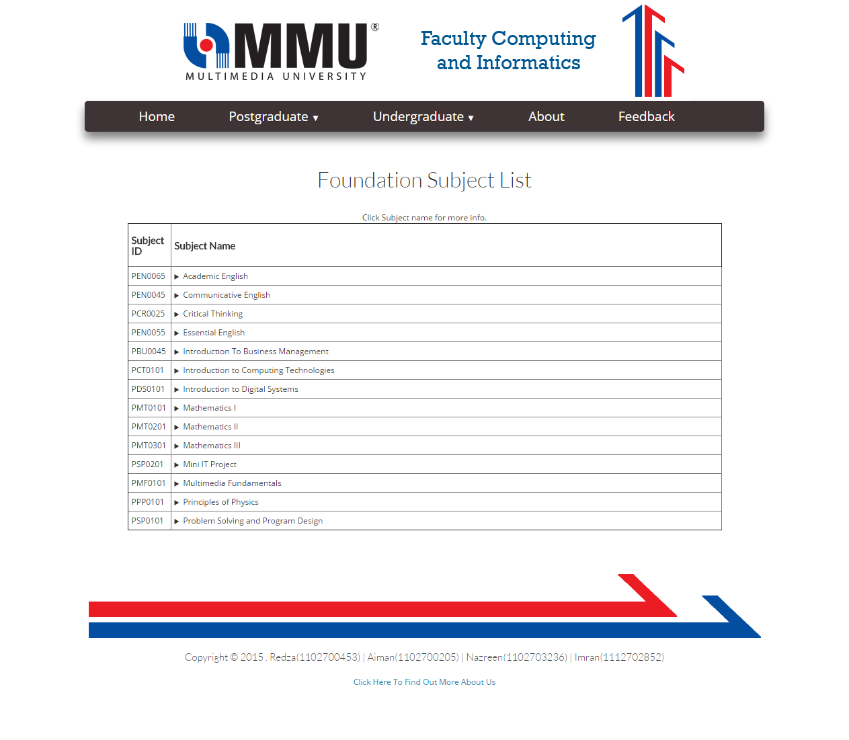
Image 4 : Subject List for Foundation

<!--foundation.html-->
<html>
<head>
<title>Foundation</title>
<link rel="icon" type="image/png" href="image/pagecon.png">
<meta charset=”utf-8”>
<meta name="viewport" content="width=device-width, initial-scale=1">
<link rel="stylesheet" href="css/bootstrap.css">
<link rel="stylesheet" href="css/page.css">

<style>

table, th, td {
border-collapse: collapse;
}

th, td {
padding: 5px;
text-align: left;

}
</style>

</head>

<body width="80%" style="margin:auto">
<center>
<a href="http://tis2151.github.io/"><img src="image/header.png" alt="header logo"></a><br>

<div class="menu-wrap">
<nav class="menu">
<ul class="clearfix">
<li><a href="http://tis2151.github.io/">Home</a></li>
<li><a href="#">Postgraduate <span class="arrow">&#9660;</span></a>
<ul class="sub-menu">
<li><a href="programmes.html">Programmes</a></li>
<li><a href="research.html">Research Centres</a></li>
</ul>
</li>
<li><a href="#">Undergraduate <span class="arrow">&#9660;</span></a>
<ul class="sub-menu">
<li><a href="foundation.html">Subject List for Foundation Programme</a></li>
<li><a href="bachelor.html">Subject List for B.CS with Specialization</a></li>
</ul>
</li>
<li><a href="about.html">About</a></li>
<li><a href="feedback.html">Feedback</a></li>
</ul>
</nav>
</div>
<br>

<!--CONTENT START HERE-->

<h2>Foundation Subject List</h2><br>

<table border="1" width="70%">
<caption>Click Subject name for more info.</caption>
<tr>

<th><h5><strong>Subject ID</strong></h5></th>
<th colspan="2" width="100%"><h5><strong>Subject Name</strong></h5></th>

</tr>

<tr>
<td >PEN0065</td>
<td ><details><summary>Academic English</summary><ul>
<li> <h3>Objective of the course in the programme :</h3> To enhance proficiency and competence in the English language to an advanced level with particular emphasis on
written communication for academic purposes </li><br>
<li> <h3>Justification for including the course in the programme :</h3> To equip students with higher level language skills in English
</li>

</ul></details></td>
</tr>

<tr>
<td >PEN0045</td>
<td ><details><summary>Communicative English</summary><ul>

<li><h3>Objective of the course in the programme :</h3> To enhance proficiency and competence in the English language to an advanced level with particular emphasis on
listening and speaking skills for general purposes</li><br>

<li> <h3>Justification for including the course in the programme :</h3> To equip students with a higher level of communication competence</li>

</ul>
</details>
</td>
</tr>

<tr>
<td >PCR0025</td>
<td ><details><summary>Critical Thinking</summary><ul>

<li><h3>Objective of the course in the programme :</h3> To expose students to the critical thinking skills</li><br>

<li> <h3>Justification for including the course in the programme :</h3> To equip the students with the analytical and reasoning skills
</li>

</ul>
</details>
</td>
</tr>

<tr>
<td >PEN0055</td>
<td ><details><summary>Essential English</summary><ul>

<li><h3>Objective of the course in the programme :</h3>To enhance proficiency and competence in the English language to an advanced level with particular emphasis on
reading skills and grammar for academic purposes</li><br>

<li> <h3>Justification for including the course in the programme :</h3>To equip students with a higher level of competence in academic English
</li>

</ul>
</details>
</td>
</tr>

<tr>
<td >PBU0045</td>
<td ><details><summary>Introduction To Business Management</summary><ul>

<li><h3>Rationale for the inclusion of the subject in the programme :</h3>To provide students with the understanding of principles of business and management and the ability
to identify, formulate and solve business and management related problems</li><br>

</ul>
</details>
</td>
</tr>

<tr>
<td >PCT0101</td>
<td ><details><summary>Introduction to Computing Technologies</summary><ul>

<li><h3>Objective of the course in the programme :</h3> To equip students with knowledge of computing technologies and ability to manipulate hardware and
software components. </li><br>
<li> <h3>Justification for including the course in the programme :</h3> To provide students with general computing knowledge and computer assembly skills. </li>

</ul>
</details>
</td>
</tr>

<tr>
<td >PDS0101</td>
<td ><details><summary>Introduction to Digital Systems</summary><ul>

<li><h3>Objective of the course in the programme :</h3> To equip students with knowledge of number systems and ability to design logic circuits. </li><br>
<li> <h3>Justification for including the course in the programme :</h3>To provide students with fundamental concepts in Digital Systems.</li>

</ul>
</details>
</td>
</tr>

<tr>
<td >PMT0101</td>
<td ><details><summary>Mathematics I</summary><ul>

<li><h3>Objective of the course in the programme :</h3>To equip students with basic knowledge and fundamental principles of Mathematics for IT students.</li><br>
<li> <h3>Justification for including the course in the programme :</h3>To provide students with sound understanding of basic mathematical concepts</li>

</ul>
</details>
</td>
</tr>

<tr>
<td >PMT0201</td>
<td ><details><summary>Mathematics II</summary><ul>

<li><h3>Objective of the course in the programme :</h3>To provide students with sound understanding of the basic mathematical concepts
</li><br>
<li> <h3>Justification for including the course in the programme :</h3>

</ul>
</details>
</td>
</tr>

<tr>
<td >PMT0301</td>
<td ><details><summary>Mathematics III</summary><ul>

<li><h3>Objective of the course in the programme :</h3>To equip students with basic knowledge and principles of Mathematics for IT students</li><br>
<li> <h3>Justification for including the course in the programme :</h3>To provide students with a sound understanding of the basic mathematical concepts.
</li>

</ul>
</details>
</td>
</tr>

<tr>
<td >PSP0201</td>
<td ><details><summary>Mini IT Project</summary><ul>

<li><h3>Objective of the course in the programme :</h3>To apply the learned problem solving skills to analyse, design, and implement a mini programming
project.</li><br>
<li> <h3>Justification for including the course in the programme :</h3>To provide students with the ability to identify, formulate and solve small IT related problems by
applying the knowledge on problem solving skills in programming. </li>

</ul>
</details>
</td>
</tr>

<tr>
<td >PMF0101</td>
<td ><details><summary>Multimedia Fundamentals</summary><ul>

<li><h3>Objective of the course in the programme :</h3>To equip students with knowledge of multimedia elements andability to create multimedia contents and
web pages. </li><br>
<li> <h3>Justification for including the course in the programme :</h3>To expose students to the fundamental concepts of multimedia elements and skills required for
multimedia content and web development</li>
</ul>
</details>
</td>
</tr>

<tr>
<td >PPP0101</td>
<td ><details><summary>Principles of Physics</summary><ul>

<li><h3>Objective of the course in the programme :</h3>To introduce laws, principles and concepts of Physics particularly Mechanics, Waves and Optics in
order to solve related problems.</li><br>

<li> <h3>Justification for including the course in the programme :</h3>To provide students with understanding of fundamental Physics concepts.</li>

</ul>
</details>
</td>
</tr>

<tr>
<td >PSP0101</td>
<td ><details><summary>Problem Solving and Program Design</summary><ul>

<li><h3>Objective of the course in the programme :</h3>To equip students with problem solving and program design skills to solve IT related problems using
suitable tools. </li><br>
<li> <h3>Justification for including the course in the programme :</h3>To expose students to problem solving approaches and program design techniques.
</li>

</ul>
</details>
</td>
</tr>

</table>

<!--CONTENT END HERE-->

<h3>&nbsp;</h3>
<table>
<tr><td style="text-align: center;"><img src="http://i.imgur.com/W01bvc0.png" alt="external link footer image"></td></tr>
<tr><td style="text-align: center;"><h5>Copyright &copy; 2015 . Redza(1102700453) | Aiman(1102700205) | Nazreen(1102703236) | Imran(1112702852)</h5></td></tr>
<tr><td style="text-align: center;"><a href="aboutus.html">Click Here To Find Out More About Us</a></td></tr>
</table>

<h1>&nbsp;</h1>
</center>
</body>
</html>

5. Bachelor Subject List
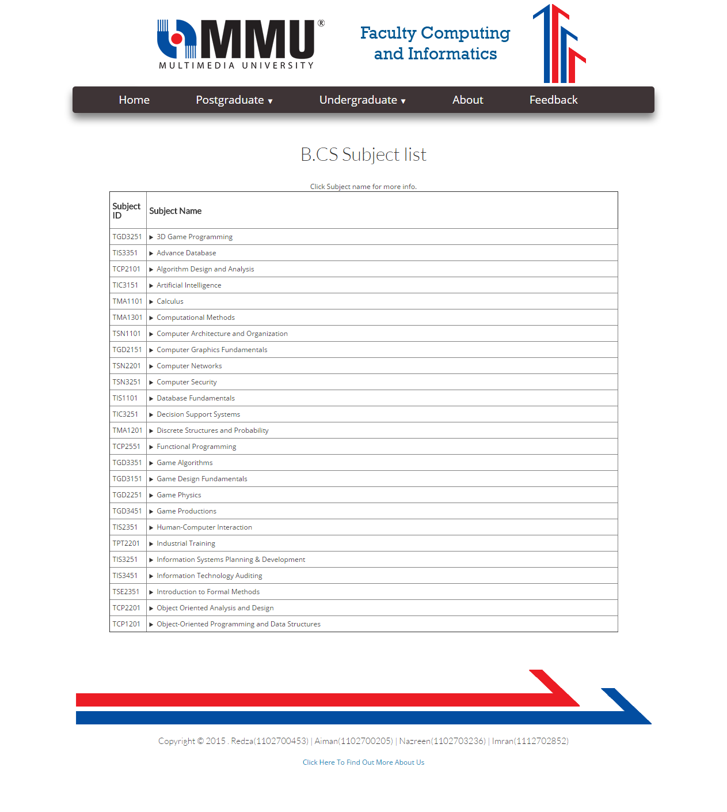
Image 5 : Subject List For Bachelor

<!--bachelor.html-->
<html>
<head>
<title>Bachelor</title>
<link rel="icon" type="image/png" href="image/pagecon.png">
<meta charset=”utf-8”>
<meta name="viewport" content="width=device-width, initial-scale=1">
<link rel="stylesheet" href="css/bootstrap.css">
<link rel="stylesheet" href="css/page.css">

<style>

table, th, td {
border-collapse: collapse;
}

th, td {
padding: 5px;
text-align: left;

}
</style>

</head>

<body width="80%" style="margin:auto">
<center>
<a href="http://tis2151.github.io/"><img src="image/header.png" alt="header logo"></a><br>

<div class="menu-wrap">
<nav class="menu">
<ul class="clearfix">
<li><a href="http://tis2151.github.io/">Home</a></li>
<li><a href="#">Postgraduate <span class="arrow">&#9660;</span></a>
<ul class="sub-menu">
<li><a href="programmes.html">Programmes</a></li>
<li><a href="research.html">Research Centres</a></li>
</ul>
</li>
<li><a href="#">Undergraduate <span class="arrow">&#9660;</span></a>
<ul class="sub-menu">
<li><a href="foundation.html">Subject List for Foundation Programme</a></li>
<li><a href="bachelor.html">Subject List for B.CS with Specialization</a></li>
</ul>
</li>
<li><a href="about.html">About</a></li>
<li><a href="feedback.html">Feedback</a></li>
</ul>
</nav>
</div>
<br>

<!--CONTENT START HERE-->

<h2>B.CS Subject list</h2><br>

<table border="1" width="70%">
<caption>Click Subject name for more info.</caption>
<tr>

<th><h5><strong>Subject ID</strong></h5></th>
<th colspan="2" width="100%"><h5><strong>Subject Name</strong></h5></th>

</tr>

<tr>
<td >TGD3251</td>
<td ><details><summary>3D Game Programming</summary><ul>

<li><h3>Objective of the course in the programme :</h3>To equip students with 3D game programming and development within the PC/Windows environment.</li><br>
<li> <h3>Justification for including the course in the programme :</h3>To provide student with the skills and techniques to develop 3D games using appropriate tools.
</li>

</ul>
</details>
</td>
</tr>

<tr>
<td >TIS3351</td>
<td ><details><summary>Advance Database</summary><ul>

<li><h3>Objective of the course in the programme :</h3>To strengthen students' understanding on database systems and provide broader aspects of management
(data mining and warehousing) and development of databases.</li><br>
<li> <h3>Justification for including the course in the programme :</h3>To prepare graduates to understand, plan, design, implement and manage various kinds of databases
ranging from traditional databases to XML databases
</li>

</ul>
</details>
</td>
</tr>

<tr>
<td >TCP2101</td>
<td ><details><summary>Algorithm Design and Analysis</summary><ul>

<li><h3>Objective of the course in the programme :</h3> To introduce algorithm design techniques through the study of algorithms from various design
paradigms.</li><br>
<li> <h3>Justification for including the course in the programme :</h3>To provide students with good analytical and design skills in computer algorithm. </li>

</ul>
</details>
</td>
</tr>

<tr>
<td >TIC3151</td>
<td ><details><summary>Artificial Intelligence</summary><ul>

<li><h3>Objective of the course in the programme :</h3> To equip students with principles and methods in artificial intelligence such as search techniques, logic,
knowledge representation techniques and alternate ways of representing knowledge as well as explore the
consequences of the various representations in AI problem solving.</li><br>
<li> <h3>Justification for including the course in the programme :</h3>To provide students with AI knowledge of search, logic and various knowledge representations for AI problem
solving.</li>

</ul>
</details>
</td>
</tr>

<tr>
<td >TMA1101</td>
<td ><details><summary>Calculus</summary><ul>

<li><h3>Objective of the course in the programme :</h3>To equip students with various essential mathematical concepts and analytical techniques for problem
solving. </li><br>
<li> <h3>Justification for including the course in the programme :</h3>To provide students with basic mathematical skills for use in subsequent courses.</li>

</ul>
</details>
</td>
</tr>

<tr>
<td >TMA1301</td>
<td ><details><summary>Computational Methods</summary><ul>

<li><h3>Objective of the course in the programme :</h3> To equip students with knowledge of computational methods and ability to manipulate software in solving
mathematical problems.</li><br>
<li> <h3>Justification for including the course in the programme :</h3>To provide students with general computational methods knowledge and problem solving skills using software.
</li>

</ul>
</details>
</td>
</tr>

<tr>
<td >TSN1101</td>
<td ><details><summary>Computer Architecture and Organization</summary><ul>

<li><h3>Objective of the course in the programme :</h3>To provide the knowledge of how the data can be represented and how the different arithmetic
operations can be done using different types of number systems and codes.
</li>

</ul>
</details>
</td>
</tr>

<tr>
<td >TGD2151</td>
<td ><details><summary>Computer Graphics Fundamentals</summary><ul>
</tr>
<li><h3>Objective of the course in the programme :</h3>To equip students with program writing skill from a practical specification and produce realistic
graphics output</li><br>
<li> <h3>Justification for including the course in the programme :</h3>To provide students with knowledge on graphics pipeline, graphic rendering, interactive and real-time
graphics development and technical programming skill to produce realistic and smooth graphics output.</li>

</ul>
</details>
</td>
</tr>

<tr>
<td >TSN2201</td>
<td ><details><summary>Computer Networks</summary><ul>

<li><h3>Objective of the course in the programme :</h3>To understand the fundamental concepts of data communications and networking in architecture,
protocol, security, management LAN and WAN</li></br>
<li> <h3>Justification for including the course in the programme :</h3>This course provides students with the knowledge required to perform basic network setup and
configuration</li>

</ul>
</details>
</td>
</tr>

<tr>
<td >TSN3251</td>
<td ><details><summary>Computer Security</summary><ul>

<li><h3>Objective of the course in the programme :</h3>To understand the building blocks and mathematical foundation of cryptography.
</li><br>
<li> <h3>Justification for including the course in the programme :</h3>To provide students with more in-depth theoretical foundations on computer security
</li>

</ul>
</details>
</td>
</tr>

<tr>
<td >TIS1101</td>
<td ><details><summary>Database Fundamentals</summary><ul>

<li><h3>Objective of the course in the programme :</h3>To equip students with knowledge of computer databases focusing on design, implementation,
recovery, concurrency, and integrity of relational databases
</li><br>
<li> <h3>Justification for including the course in the programme :</h3>To prepare students with the skills to plan, design and manage database systems.
</li>

</ul>
</details>
</td>

<tr>
<td >TIC3251</td>
<td ><details><summary>Decision Support Systems</summary><ul>

<li><h3>Objective of the course in the programme :</h3>To understand the concepts, methodologies and technologies of Decision Support Systems and
application to real world problems
</li><br>
<li> <h3>Justification for including the course in the programme :</h3>To understand the concepts, methodologies and technologies of Decision Support Systems and
application to real world problems
</li>

</ul>
</details>
</td>
</tr>

<tr>
<td >TMA1201</td>
<td ><details><summary>Discrete Structures and Probability</summary><ul>

<li><h3>Objective of the course in the programme :</h3>To equip students with knowledge of various discrete structures and basic concepts of probability
</li><br>
<li> <h3>Justification for including the course in the programme :</h3>To provide basic knowledge of discrete structures and probability required for computer science
courses.
</li>

</ul>
</details>
</td>
</tr>

<tr>
<td >TCP2551</td>
<td ><details><summary>Functional Programming</summary><ul>

<li><h3>Objective of the course in the programme :</h3>This course introduces the functional programming paradigm and the implementation technology for
functional programming languages. It aims to develop a broad understanding of the benefits of the
functional programming style, together with an understanding of implementation issues that are
relevant not only to functional languages but also to other systems that require automatic dynamic
memory management
</li><br>
<li> <h3>Justification for including the course in the programme :</h3>write programs in a functional style and be able to use the language to implement algorithms
and data types to solve problems.
</li>
</ul>
</details>
</td>
</tr>
<tr>
<td >TGD3351</td>
<td ><details><summary>Game Algorithms</summary><ul>

<li><h3>Objective of the course in the programme :</h3>To equip students with the fundamental algorithms and concepts in game programming and artificial
intelligence (AI) and to provide exposure to hands-on game development and application of relevant game
algorithms.
</li><br>
<li> <h3>Justification for including the course in the programme :</h3>To provide students with knowledge of fundamental algorithms in game programming and exposure to
hands-on game development
</li>

</ul>
</details>
</td>
</tr>

<tr>
<td >TGD3151</td>
<td ><details><summary>Game Design Fundamentals</summary><ul>

<li><h3>Objective of the course in the programme :</h3>To equip students with the fundamental knowledge of game design and ability to create
basic game mechanics using scripting language.
</li><br>
<li> <h3>Justification for including the course in the programme :</h3>To provide students with fundamental game design knowledge and game scripting skills.
</li>

</ul>
</details>
</td>
</tr>

<tr>
<td >TGD2251</td>
<td ><details><summary>Game Physics</summary><ul>

<li><h3>Objective of the course in the programme :</h3>• To expose students to the importance of mathematics and physics in game design and development
</li><br>
<li> <h3>Justification for including the course in the programme :</h3>To provide students sufficient knowledge and skills to implement physics in game development.
</li>

</ul>
</details>
</td>
</tr>

<tr>
<td >TGD3451</td>
<td ><details><summary>Game Productions</summary><ul>
<li><h3>Objective of the course in the programme :</h3>To equip students with knowledge of game productions and ability to managethe game production
process in game development environment.
</li><br>
<li> <h3>Justification for including the course in the programme :</h3>To provide students with general game production knowledge and game prototyping skills.
</li>

</ul>
</details>
</td>
</tr>

<tr>
<td >TIS2351</td>
<td ><details><summary>Human-Computer Interaction</summary><ul>

<li><h3>Objective of the course in the programme :</h3>To introduce the concept of Human-Computer Interaction (HCI), interaction design methodologies,
systematic methodologies for evaluating user interface and advanced issues in HCI.
</li><br>
<li> <h3>Justification for including the course in the programme :</h3>To provide students with user-centered design skills required to create usable interfaces with any
technology.
</li>
</ul>
</details>
</td>
</tr>

<tr>
<td >TPT2201</td>
<td ><details><summary>Industrial Training</summary><ul>

<li><h3>Objective of the course in the programme :</h3>To expose students to the real working environment and to get familiarity with the organization
structure, business operations and administrative functions.
</li><br>
<li> <h3>Justification for including the course in the programme :</h3>To provide students practical experience, relevant and current knowledge, and soft skills necessary for better
preparation to face the working world upon graduation and also to have a competitive edge in the job market.
</li>
</ul>
</details>
</td>
</tr>

<tr>
<td >TIS3251</td>
<td ><details><summary>Information Systems Planning & Development</summary><ul>

<li><h3>Objective of the course in the programme :</h3>To expose students to processes and techniques in planning and developing information systems
</li><br>
<li> <h3>Justification for including the course in the programme :</h3>To provide students with the knowledge on how information systems are planned and developed using a
variety of techniques and tools.
</li>
</tr>
</ul>
</details>
</td>
</tr>

<tr>
<td >TIS3451</td>
<td ><details><summary>Information Technology Auditing</summary><ul>

<li><h3>Objective of the course in the programme :</h3>To understand the concepts of Information Technology (IT) governance, IT auditing, risks and
controls associated to information systems development and maintenance.

</li><br>
<li> <h3>Justification for including the course in the programme :</h3>To expose students to various information systems controls and auditing techniques
</li>

</ul>
</details>
</td>
</tr>

<tr>
<td >TSE2351</td>
<td ><details><summary>Introduction to Formal Methods</summary><ul>

<li><h3>Objective of the course in the programme :</h3> To inculcate awareness of formal methods and their relevance to software engineering
</li><br>
<li> <h3>Justification for including the course in the programme :</h3>Within the field of software engineering, there is an area called formal software engineering. This
subject serves to introduce students to basic modelling techniques in formal software engineering
</li>

</ul>
</details>
</td>
</tr>

<tr>
<td >TCP2201</td>
<td ><details><summary>Object Oriented Analysis and Design</summary><ul>

<li><h3>Objective of the course in the programme :</h3>To equip students with knowledge of fundamental principles of object-oriented analysis and design techniques and
its effects on the implementation of a software system
</li><br>
<li> <h3>Justification for including the course in the programme :</h3>To provide students with object-oriented analysis and design concept for large scale programming or application
development.
</li>

</ul>
</details>
</td>

<tr>
<td >TCP1201</td>
<td ><details><summary>Object-Oriented Programming and Data Structures</summary><ul>

<li><h3>Objective of the course in the programme :</h3>To equip students with knowledge of formulating problems from object-oriented
perspective, and then solve the problems using C++ programming languages and
elementary data structures.
</li><br>
<li> <h3>Justification for including the course in the programme :</h3>To provide students with object-oriented programming skills.
</li>

</ul>
</details>
</td>
</tr>

</table>

<!--CONTENT END HERE-->

<h3>&nbsp;</h3>
<table>
<tr><td style="text-align: center;"><img src="http://i.imgur.com/W01bvc0.png" alt="external link footer image"></td></tr>
<tr><td style="text-align: center;"><h5>Copyright &copy; 2015 . Redza(1102700453) | Aiman(1102700205) | Nazreen(1102703236) | Imran(1112702852)</h5></td></tr>
<tr><td style="text-align: center;"><a href="aboutus.html">Click Here To Find Out More About Us</a></td></tr>
</table>

<h1>&nbsp;</h1>
</center>
</body>
</html>

6. About
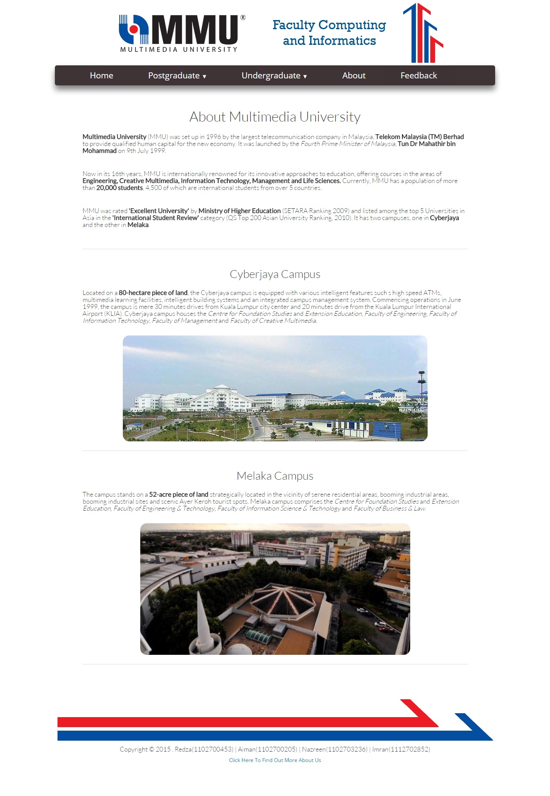
Image 6 : About Page
<!--about.html-->
<!DOCTYPE html>
<html>
<head>
<title>About</title>
<meta charset="utf-8" />
<link rel="icon" type="image/png" href="image/pagecon.png">
<meta charset=�utf-8�>
<meta name="viewport" content="width=device-width, initial-scale=1">
<link rel="stylesheet" href="css/bootstrap.css">
<link rel="stylesheet" href="css/page.css">

</head>

<body>

<body width="80%" style="margin:auto">
<center>
<a href="http://tis2151.github.io/"><img src="image/header.png" alt="header logo"></a><br>

<div class="menu-wrap">
<nav class="menu">
<ul class="clearfix">
<li><a href="http://tis2151.github.io/">Home</a></li>
<li><a href="#">Postgraduate <span class="arrow">&#9660;</span></a>
<ul class="sub-menu">
<li><a href="programmes.html">Programmes</a></li>
<li><a href="research.html">Research Centres</a></li>
</ul>
</li>
<li><a href="#">Undergraduate <span class="arrow">&#9660;</span></a>
<ul class="sub-menu">
<li><a href="foundation.html">Subject List for Foundation Programme</a></li>
<li><a href="bachelor.html">Subject List for B.CS with Specialization</a></li>
</ul>
</li>
<li><a href="about.html">About</a></li>
<li><a href="feedback.html">Feedback</a></li>
</ul>
</nav>
</div>
<br>

<!--CONTENT START HERE-->

<table width="70%">
<tr><th style="text-align: center;"><h2>About Multimedia University</h2></th></tr>

<tr>
<td><h5><strong>Multimedia University</strong> (MMU) was set up in 1996 by the largest telecommunication company in Malaysia, <strong>Telekom Malaysia (TM) Berhad</strong> to provide qualified human capital for the new economy.
It was launched by the <i>Fourth Prime Minister of Malaysia</i>, <strong>Tun Dr Mahathir bin Mohammad</strong> on 9th July 1999.</h5><br></td>
</tr>
<tr>
<td><h5>Now in its 16th years, MMU is internationally renowned for its innovative approaches to education, offering courses in the areas of <strong>Engineering, Creative Multimedia, Information Technology, Management and Life Sciences.</strong>
Currently, MMU has a population of more than <strong>20,000 students</strong>, 4,500 of which are international students from over 5 countries.</h5><br></td>
</tr>
<tr>
<td><h5>MMU was rated <strong>'Excellent University'</strong> by <strong>Ministry of Higher Education</strong> (SETARA Ranking 2009) and listed among the top 5 Universities in Asia in the <strong>'International Student Review'</strong> category (QS Top 200 Asian University Ranking, 2010).
It has two campuses, one in <strong>Cyberjaya</strong> and the other in <strong>Melaka</strong>.</h5><br><hr></td>
</tr>
</table>

<table width="70%">
<tr><th style="text-align: center;"><h3>Cyberjaya Campus</h3></th></tr>

<tr>
<td><h5>Located on a <strong>80-hectare piece of land</strong>, the Cyberjaya campus is equipped with various intelligent features such s high speed ATMs, multimedia learning facilities, intelligent building systems and an integrated campus management system.
Commencing operations in June 1999, the campus is mere 30 minutes drives from Kuala Lumpur city center and 20 minutes drive from the Kuala Lumpur International Airport (KLIA). Cyberjaya campus houses the <i>Centre for Foundation Studies</i> and
<i>Extension Education, Faculty of Engineering, Faculty of Information Technology, Faculty of Management</i> and <i>Faculty of Creative Multimedia</i>.</h5><br></td>
</tr>
<tr>
<td style="text-align: center;"><img class="rcorners3" src="image/campus.jpg" alt="Internal Image Cyberjaya Campus"><br><hr></td>
</table>

<table width="70%">
<tr><th style="text-align: center;"><h3>Melaka Campus</h3></th></tr>

<tr>
<td><h5>The campus stands on a <strong>52-acre piece of land</strong> strategically located in the vicinity of serene residential areas, booming industrial areas, booming industrial sites and scenic Ayer Keroh tourist spots.
Melaka campus comprises the <i>Centre for Foundation Studies</i> and <i>Extension Education, Faculty of Engineering & Technology, Faculty of Information Science & Technology</i> and <i>Faculty of Business & Law</i>.</h5><br></td>
</tr>
<tr>
<td style="text-align: center;"><img class="rcorners3" src="https://www.mmu.edu.my/upfiles/dm948_melaka_campus.jpg" alt="External Image Melaka Campus"><br><hr></td>
</table>

<!--CONTENT END HERE-->

<h3>&nbsp;</h3>
<table>
<tr><td style="text-align: center;"><img src="http://i.imgur.com/W01bvc0.png" alt="external link footer image"></td></tr>
<tr><td style="text-align: center;"><h5>Copyright &copy; 2015 . Redza(1102700453) | Aiman(1102700205) | Nazreen(1102703236) | Imran(1112702852)</h5></td></tr>
<tr><td style="text-align: center;"><a href="aboutus.html">Click Here To Find Out More About Us</a></td></tr>
</table>
<h1>&nbsp;</h1>
</center>
</body>
</html>

7. Feedback Form
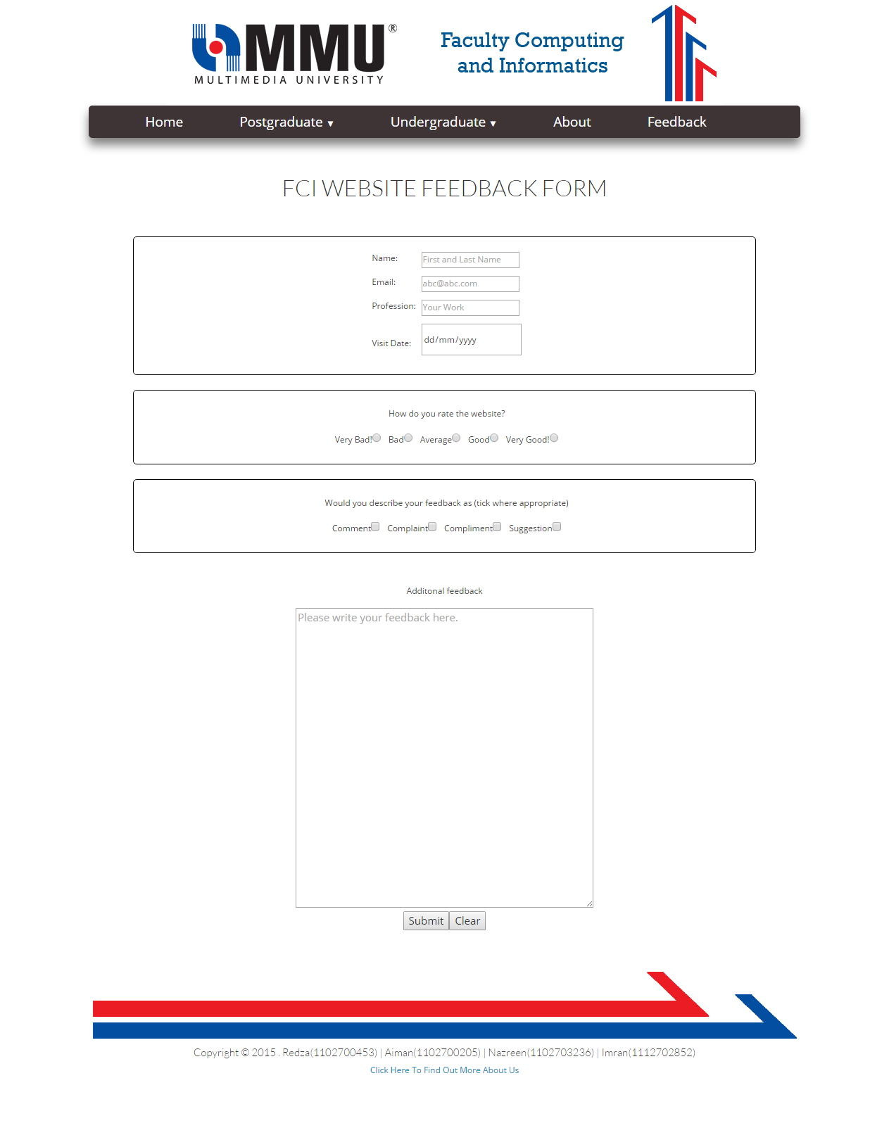
Image 7 : Feedback Form Page
<!--feedback.html-->
<!DOCTYPE html>
<html>
<head>
<title>Feedback Form</title>
<meta charset="utf-8" />
<link rel="icon" type="image/png" href="image/pagecon.png">
<meta charset=”utf-8”>
<meta name="viewport" content="width=device-width, initial-scale=1">
<link rel="stylesheet" href="css/bootstrap.css">
<link rel="stylesheet" href="css/page.css">

</head>

<body width="80%" style="margin:auto">
<center>
<a href="http://tis2151.github.io/"><img src="image/header.png" alt="header logo"></a><br>

<div class="menu-wrap">
<nav class="menu">
<ul class="clearfix">
<li><a href="http://tis2151.github.io/">Home</a></li>
<li><a href="#">Postgraduate <span class="arrow">&#9660;</span></a>
<ul class="sub-menu">
<li><a href="programmes.html">Programmes</a></li>
<li><a href="research.html">Research Centres</a></li>
</ul>
</li>
<li><a href="#">Undergraduate <span class="arrow">&#9660;</span></a>
<ul class="sub-menu">
<li><a href="foundation.html">Subject List for Foundation Programme</a></li>
<li><a href="bachelor.html">Subject List for B.CS with Specialization</a></li>
</ul>
</li>
<li><a href="about.html">About</a></li>
<li><a href="feedback.html">Feedback</a></li>
</ul>
</nav>
</div>
<br>

<!--CONTENT START HERE-->

<div class="container-feedback">
<p><h2>FCI WEBSITE FEEDBACK FORM</h2></p><br><br>
<div class="form">
<form method="post" action="thankyoupage.html">
<div class = "box1">
<br>
<!-- Name -->
<table>
<tr><td><p><label for="name" > &nbsp Name:</label></td>
<td><span style = "margin-left : 5%"><input name="name" type="text" id="name" required placeholder="First and Last Name" autocomplete="off" /></span></p>
</td></tr>
<!-- Email -->
<tr><td><p><label for="email">&nbsp Email:</label></td>
<td><span style = "margin-left : 5%"><input name="email" type="email" id="email" required placeholder="abc@abc.com" autocomplete="off" /></span></p>
</td></tr>
</div>
<!-- Profesion -->
<tr><td><p><label for="profesion">&nbsp Profession:</label></td>
<td><span style = "margin-left : 5%"><input name="profesion" type="text" id="profesion" required placeholder="Your Work" list="profesions" autocomplete="off"/></span></p>
<datalist id="profesions">
<option value="Student"></option>
<option value="Lecturer"></option>
<option value="MMU staff"></option>
<option value="Unemployed"></option>
</datalist></td></tr>
<!-- Date of Visit -->
<tr><td><p><label for="date-visit">&nbsp Visit Date: </label></td>
<td><span style = "margin-left : 5%"><input name="date-visit" type="date" id="date-visit" required /></span></p><br></td></tr>
</table>
</div>
<br>
<!-- Radio Button for rating -->
<div class = "box2">
<br>
<p><label>&nbsp How do you rate the website?</label></p>
<span>
<label for="1">&nbsp Very Bad!</label><input name="rating" type="radio" value="1" id="1" required />
<label for="2">&nbsp Bad</label><input name="rating" type="radio" value="2" id="2" required />
<label for="3">&nbsp Average</label><input name="rating" type="radio" value="3" id="3" required />
<label for="4">&nbsp Good</label><input name="rating" type="radio" value="4" id="4" required />
<label for="5">&nbsp Very Good!</label><input name="rating" type="radio" value="5" id="5" required /><br><br>
</span>
</div>
<br>
<!-- Check Box List -->
<div class = "box2">
<br>
<p><label>&nbsp Would you describe your feedback as (tick where appropriate)</label></p>
<span>
<label for="10">&nbsp Comment</label><input name="feedback" type="checkbox" value="1" id="10" />
<label for="20">&nbsp Complaint</label><input name="feedback" type="checkbox" value="2" id="20" />
<label for="30">&nbsp Compliment</label><input name="feedback" type="checkbox" value="3" id="30" />
<label for="40">&nbsp Suggestion</label><input name="feedback" type="checkbox" value="4" id="40" /><br><br>
</span>
</div>
<!-- Additional Comments -->
<br><br><p><label for="additional-feedback">Additonal feedback</label></p>
<textarea name="additional-feedback" placeholder="Please write your feedback here." id="additional-feedback" rows = "20" cols = "50" ></textarea>
<!-- Submit and Clear Button -->
<p><input type="submit" value="Submit" class="button-submit" /><input type="reset" value="Clear" class="button-reset" /></p>

</form>
</div>

<!--CONTENT END HERE-->

<h3>&nbsp;</h3>
<table>
<tr><td style="text-align: center;"><img src="http://i.imgur.com/W01bvc0.png" alt="external link footer image"></td></tr>
<tr><td style="text-align: center;"><h5>Copyright &copy; 2015 . Redza(1102700453) | Aiman(1102700205) | Nazreen(1102703236) | Imran(1112702852)</h5></td></tr>
<tr><td style="text-align: center;"><a href="aboutus.html">Click Here To Find Out More About Us</a></td></tr>
</table>

<h1>&nbsp;</h1>
</center>
</body>
</html>

8. Thank You
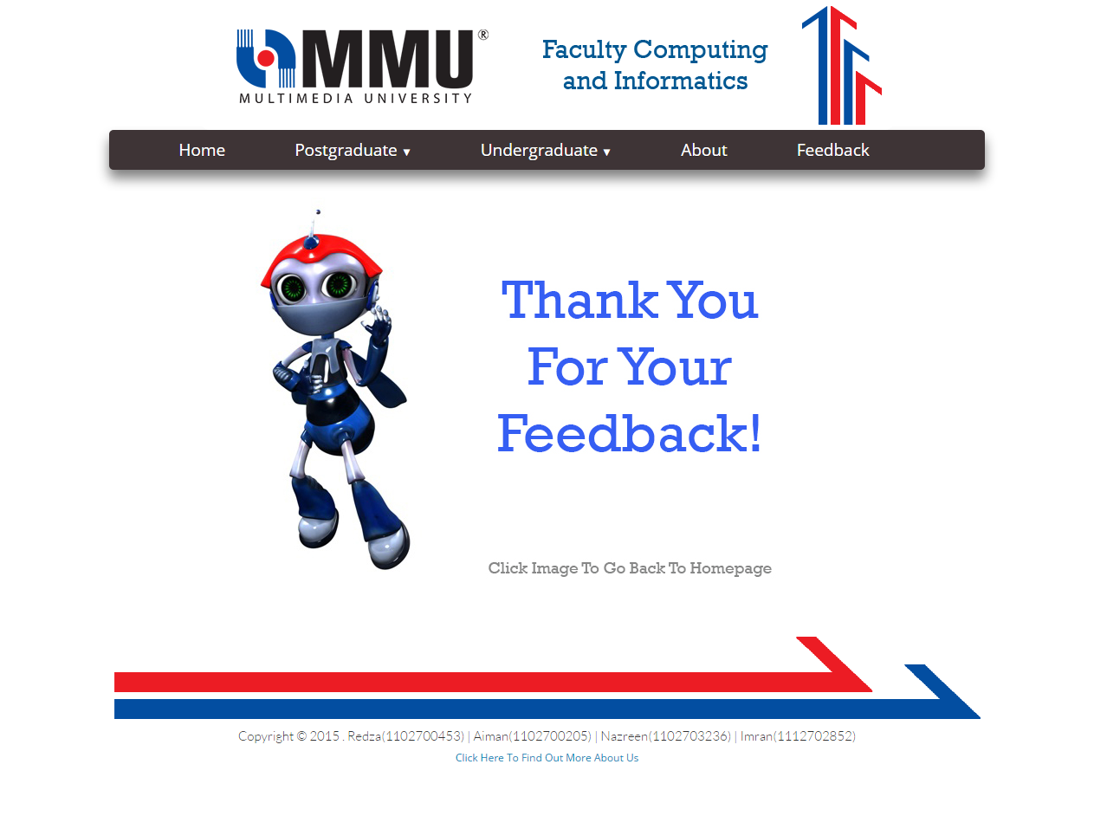
Image 8 : Thank You Page
<!--thankyoupage.html-->
<!DOCTYPE html>
<html>
<head>
<title>Thank You!</title>
<meta charset="utf-8" />
<link rel="icon" type="image/png" href="image/pagecon.png">
<meta charset=”utf-8”>
<meta name="viewport" content="width=device-width, initial-scale=1">
<link rel="stylesheet" href="css/bootstrap.css">
<link rel="stylesheet" href="css/page.css">

</head>

<body>

<body width="80%" style="margin:auto">
<center>
<a href="http://tis2151.github.io/"><img src="image/header.png" alt="header logo"></a><br>

<div class="menu-wrap">
<nav class="menu">
<ul class="clearfix">
<li><a href="http://tis2151.github.io/">Home</a></li>
<li><a href="#">Postgraduate <span class="arrow">&#9660;</span></a>
<ul class="sub-menu">
<li><a href="programmes.html">Programmes</a></li>
<li><a href="research.html">Research Centres</a></li>
</ul>
</li>
<li><a href="#">Undergraduate <span class="arrow">&#9660;</span></a>
<ul class="sub-menu">
<li><a href="foundation.html">Subject List for Foundation Programme</a></li>
<li><a href="bachelor.html">Subject List for B.CS with Specialization</a></li>
</ul>
</li>
<li><a href="about.html">About</a></li>
<li><a href="feedback.html">Feedback</a></li>
</ul>
</nav>
</div>
<br>

<!--CONTENT START HERE-->

<a href="http://tis2151.github.io/"><img src="image/thankyou.jpg" alt="Thank You"></a>
<br>

<!--CONTENT END HERE-->

<h3>&nbsp;</h3>
<table>
<tr><td style="text-align: center;"><img src="http://i.imgur.com/W01bvc0.png" alt="external link footer image"></td></tr>
<tr><td style="text-align: center;"><h5>Copyright &copy; 2015 . Redza(1102700453) | Aiman(1102700205) | Nazreen(1102703236) | Imran(1112702852)</h5></td></tr>
<tr><td style="text-align: center;"><a href="aboutus.html">Click Here To Find Out More About Us</a></td></tr>
</table>

<h1>&nbsp;</h1>
</center>
</body>
</html>

9. About Us
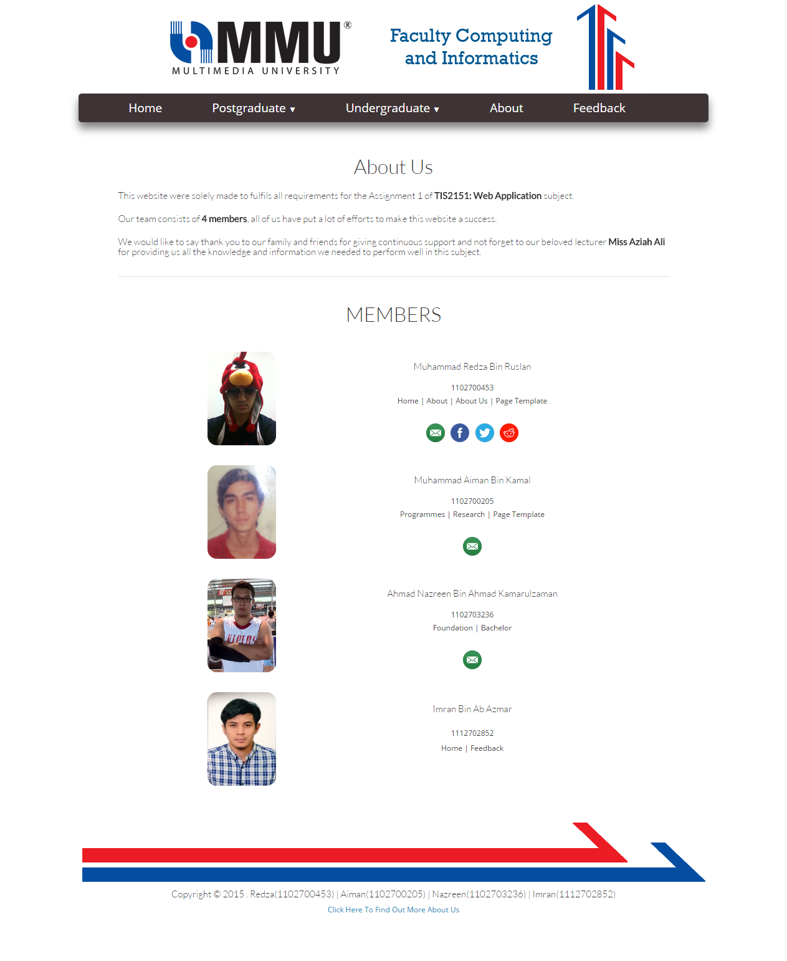
Image 9 : About Us Page
<!--aboutus.html-->
<!DOCTYPE html>
<html>
<head>
<title>About Us</title>
<meta charset="utf-8" />
<link rel="icon" type="image/png" href="image/pagecon.png">
<meta charset=�utf-8�>
<meta name="viewport" content="width=device-width, initial-scale=1">
<link rel="stylesheet" href="css/bootstrap.css">
<link rel="stylesheet" href="css/page.css">

</head>

<body>

<body width="80%" style="margin:auto">
<center>
<a href="http://tis2151.github.io/"><img src="image/header.png" alt="header logo"></a><br>

<div class="menu-wrap">
<nav class="menu">
<ul class="clearfix">
<li><a href="http://tis2151.github.io/">Home</a></li>
<li><a href="#">Postgraduate <span class="arrow">&#9660;</span></a>
<ul class="sub-menu">
<li><a href="programmes.html">Programmes</a></li>
<li><a href="research.html">Research Centres</a></li>
</ul>
</li>
<li><a href="#">Undergraduate <span class="arrow">&#9660;</span></a>
<ul class="sub-menu">
<li><a href="foundation.html">Subject List for Foundation Programme</a></li>
<li><a href="bachelor.html">Subject List for B.CS with Specialization</a></li>
</ul>
</li>
<li><a href="about.html">About</a></li>
<li><a href="feedback.html">Feedback</a></li>
</ul>
</nav>
</div>
<br>

<!--CONTENT START HERE-->

<table width="70%">
<tr>
<th colspan="2" style="text-align: center;"><h2>About Us</h2></th>
</tr>
<tr>
<td colspan="2"><h5>This website were solely made to fulfils all requirements for the Assignment 1 of <strong>TIS2151: Web Application</strong> subject.</h5></td>
</tr>
<tr>
<td colspan="2"><h5>Our team consists of <strong>4 members</strong>, all of us have put a lot of efforts to make this website a success.</h5></td>
</tr>
<tr>
<td colspan="2"><h5>We would like to say thank you to our family and friends for giving continuous support and not forget to our beloved lecturer <strong>Miss Aziah Ali</strong>
</td>
for providing us all the knowledge and information we needed to perform well in this subject.</h5></td>
</tr>
<tr>
<th colspan="2" style="text-align: center;"><hr></th>
</tr>

<tr>
<th colspan="2" style="text-align: center;"><h2>MEMBERS</h2></th>
</tr>

<tr><td><br><br></td></tr>

<tr>
<td rowspan="5" style="text-align: right;"><img class="rcorners3" src="image/red.jpg" alt="Redza" width="110px" height="150px"></td>
<td style="text-align: center;"><h5>Muhammad Redza Bin Ruslan</h5></td>
</tr>
<tr>
<td style="text-align: center;">1102700453</td>
</tr>
<tr>
<td style="text-align: center;">Home | About | About Us | Page Template</td>
</tr>
<tr>
<td><br></td>
</tr>
<tr>
<td style="text-align: center;">
<a href="mailto:redzrex@gmail.com" target="_blank"><img src="image/email.png" alt="Send to my Email" width="30px" height="30px" hspace="3"></a>
<a href="https://www.facebook.com/redzrex" target="_blank"><img src="image/facebook.png" alt="Add Me at Facebook" width="30px" height="30px" hspace="3"></a>
<a href="https://twitter.com/redzrex" target="_blank"><img src="image/twitter.png" alt="Follow Me @redzrex" width="30px" height="30px" hspace="3"></a>
<a href="https://www.reddit.com/user/redzrex/" target="_blank"><img src="image/reddit.png" alt="Message me at Reddit" width="30px" height="30px" hspace="3"></a>
</td>
</tr>

<tr><td><br><br></td></tr>

<tr>
<td rowspan="5" style="text-align: right;"><img class="rcorners3" src="image/aiman.jpg" alt="Aiman" width="110px" height="150px"></td>
<td style="text-align: center;"><h5>Muhammad Aiman Bin Kamal</h5></td>
</tr>
<tr>
<td style="text-align: center;">1102700205</td>
</tr>
<tr>
<td style="text-align: center;">Programmes | Research | Page Template</td>
</tr>
<tr>
<td><br></td>
</tr>
<tr>
<td style="text-align: center;">
<a href="mailto:aimankamal_92@yahoo.com" target="_blank"><img src="image/email.png" alt="Send to my Email" width="30px" height="30px" hspace="3"></a>
</tr>

<tr><td><br><br></td></tr>

<tr>
<td rowspan="5" style="text-align: right;"><img class="rcorners3" src="image/naz.jpg" alt="Nazreen" width="110px" height="150px"></td>
<td style="text-align: center;"><h5>Ahmad Nazreen Bin Ahmad Kamarulzaman</h5></td>
</tr>
<tr>
<td style="text-align: center;">1102703236</td>
</tr>
<tr>
<td style="text-align: center;">Foundation | Bachelor</td>
</tr>
<tr>
<td><br></td>
</tr>
<tr>
<td style="text-align: center;">
<a href="mailto:akira9212@gmail.com" target="_blank"><img src="image/email.png" alt="Send to my Email" width="30px" height="30px" hspace="3"></a>
</td>
</tr>

<tr><td><br><br></td></tr>

<tr>
<td rowspan="5" style="text-align: right;"><img class="rcorners3" src="image/imran.jpg" alt="Imran" width="110px" height="150px"></td>
<td style="text-align: center;"><h5>Imran Bin Ab Azmar</h5></td>
</tr>
<tr>
<td style="text-align: center;">1112702852</td>
</tr>
<tr>
<td style="text-align: center;">Home | Feedback</td>
</tr>
<tr>
<td><br></td>
</tr>
<tr>
<td><br></td>
</tr>

</table>

<!--CONTENT END HERE-->

<h3>&nbsp;</h3>
<table>
<tr><td style="text-align: center;"><img src="http://i.imgur.com/W01bvc0.png" alt="external link footer image"></td></tr>
<tr><td style="text-align: center;"><h5>Copyright &copy; 2015 . Redza(1102700453) | Aiman(1102700205) | Nazreen(1102703236) | Imran(1112702852)</h5></td></tr>
<tr><td style="text-align: center;"><a href="aboutus.html">Click Here To Find Out More About Us</a></td></tr>
</table>
<h1>&nbsp;</h1>
</center>
</body>
</html>

CSS Code -

body {
background:#ffffff;
}

.clearfix:after {
display:block;
clear:both;
}

/*----- Menu Outline -----*/
.menu-wrap {
width:80%;
box-shadow:0px 10px 20px rgba(0,0,0,0.5);
background:#3e3436;
border-radius: 5px;
}

.menu {
width:100%;
margin:0px auto;
}

.menu li {
margin:0px;
list-style:none;
}

.menu a {
transition:all linear 0.15s;
color:#ffffff;
}

.menu li:hover > a, .menu .current-item > a {
text-decoration:none;
color:#034EA1;
}

.menu .arrow {
font-size:11px;
line-height:0%;
}

/*----- Top Level -----*/
.menu > ul > li {
float:left;
display:inline-block;
position:relative;
font-size:19px;
}

.menu > ul > li > a {
padding:10px 40px;
display:inline-block;
text-shadow:0px 1px 0px rgba(0,0,0,0.4);
}

.menu > ul > li:hover > a, .menu > ul > .current-item > a {
background:#2e2728;
}

/*----- Bottom Level -----*/
.menu li:hover .sub-menu {
z-index:1;
opacity:1;
}

.sub-menu {
width:160%;
padding:0px 0px;
position:absolute;
top:100%;
left:-25%;
z-index:-1;
opacity:0;
transition:opacity linear 0.15s;
box-shadow:0px 2px 3px rgba(0,0,0,0.2);
background:#2e2728;
}

.sub-menu li {
display:block;
font-size:16px;
}

.sub-menu li a {
padding:10px 30px;
display:block;
}

.sub-menu li a:hover, .sub-menu .current-item a {
background:#3e3436;
}

/*-----Others-----*/
.home{
height:100%;
width:80%;
background-color:white;
position:relative;
}

.color1 {
color : black;
}

.box1{
width:70%;
height:100%;
border:1px solid black;
border-radius: 5px;
}

.box2{
width:70%;
height:100%;
border:1px solid black;
border-radius: 5px;
}

.rcorners1 {
border-radius: 15px 50px;
}

.rcorners2 {
border-radius: 50px 15px;
}

.rcorners3 {
border-radius: 15px;
}

.span{
color:#6633CC;

}

.summary{
outline: none;
}

.th, .td {
padding: 5px;
text-align: left;
outline: none;
}

